**Jim Cramer: A stock guru or social influencer?**

**Professor: Andriy Shkilko**

**August 16, 2021**

**Collaborators:**

**Ali Lakhani**

**Sineng (Joanna) Chen**

**Jianyi (Lucas) Lyu**

**Aaqib Mujtaba**

**Zihan (Hannah) Ou**

**Wenjun (Evanna) Wang**

**Yilin (Elaine) Zhang**



**Executive Summary**

The enclosed report titled *Jim Cramer: A stock guru or social influencer,* seeks to determine Jim Cramer’s ability to consistently predict and advocate undervalued stocks for his followers on Twitter. A dataset consisting of Twitter tweets from 2019 was composed by leveraging the open-sourced twitter scraper API. To establish a baseline for market returns, the S&P 500 was used as nearly 70% of all tickers mentioned by Cramer were in the S&P 500 index.

To determine Cramer’s abnormal return, the time horizons of short term (1-day, 7-day, 30-day), and long term (1-year) were used, where incremental market return vs a portfolio approach using a 5-factor regression model was leveraged. The null hypothesis for this report was that Jim Cramer’s twitter recommendation did not provide any statistically significant incremental return when compared to the market baseline. Moreover, due to Cramer’s rather sporadic, and eccentric personality, coupled with the voluminous tweeting tendency, it was hypothesized that his recommendations were lagging indicators of stock performance. As such, 1-day, 1-week, and 1-month returns leading up to a stock tweet were also used.

The results from previous studies of *How Mad is Mad Money* and *Market Madness? The case of Mad Money* indicates minimal incremental returns for Cramer’s proposed stock vs a market baseline of the S&P 500, and further indicates that a short-term reversal of price movement is likely due to volume trading by his supporters. Nevertheless, our report tests for potential improvements or shifts in Cramer’s recommendation styles since 2008. The results of this report support our null hypothesis and demonstrate that due to the negative HML Cramer focuses on growth stocks, while his positive SMB indicates a higher return from smaller cap stocks. Cramer’s recommendations are thus only marginally better than a market index, and a lagging indicator when considering pre tweet stock price movements.

1. **Introduction**

Retail and Institutional traders are typically the two types of traders that dominate the stock market. There has historically been a power discrepancy between institutional traders who perform more sophisticated trading based on advanced metrics, due diligence, and leverage, versus retail traders who consist of the general public and often rely on emotional responses and public news to perform trades. Enter Jim Cramer, who is an American TV personality, host of his own financial advisory show Mad Money on CNBC, an author, and a former hedge fund manager. To many, Cramer's background coupled with his eccentric personality and tendency to tweet stock recommendations make him the messiah retail traders have sought after. Average daily trading volume has nearly doubled since 2019, moving from “7 Billion to 14.7 Billion in 2021” (Pissani, 2021). With the emergence of zero commission trading platforms like WealthSimple, and Robinhood, it is quite likely that the majority of this increase is a result of an influx of retail order flow.

Jim Cramer is amongst the many social media influencers who have received early success in their stock proclamations, yet it is uncertain if they can truly be considered stock gurus. Our study explores Jim Cramer’s twitter history in terms of his stock recommendations and compares his returns to the S&P 500 as a benchmark. 1-day, 1-week, and 1-month returns are used to determine Cramer’s abnormal return to judge his foresight. The study also considers 1 day, 1 week, and 1 month returns leading up to Cramer’s twitter recommendation to determine his ability to anticipate stock turnarounds before significant reversals occur. Although intraday returns have been omitted from this report due to a lack of available datasets from Google, and CRSP, future steps may indicate a potential price reversal effect imposed by Cramer’s tweets due to momentum.

Bolster’s and Trahan’s paper “How Mad is Mad Money” from 2008, conducted similar research but focused on Cramer’s CNBC show. Results showed minimal difference between CAR (Cumulative abnormal return) from Cramer’s selected stocks vs the S&P 500 (market). However, there was an average short term positive growth of 1.88% in CAR [1,1] between 2005 and 2008, but then a quick reversal between CAR [2,5] and CAR [2,30] of -0.33% and -2.1% respectively. Thus, it indicates that the short-term returns are likely spurred by high volume and momentum rather than changed fundamentals. Further yet, when analyzing the positive HML (High minus Low) in early years of recommended stock, and negative HML in 2008, Cramer appears to have changed his strategy from value stocks to growth stocks over the years.

This report will serve to further investigate Crammer’s recommendation by determining if his credibility has improved since 2008, and if his strategy has changed amidst a more digital world of Twitter (Social Media) and with more experience. The report also considers the long-term return of Cramer’s stock recommendations by building a portfolio of equities and examining differences through his Bull (buy) and Bear (sell) sentiments through varying holding periods compared to the S&P 500.

Our null hypothesis is that there is no statistically significant incremental return of Jim Cramer’s stock recommendations to a benchmark of the S&P 500. Moreover, considering the rather sporadic and often manner in which Jim Cramer tweets, we also hypothesize that his recommendations rely on early market movement rather than prompting influx points himself.

1. **Data and Descriptive Statistics**

In order to conduct the study, we began data collection by scraping and analyzing tweets from Jim Cramer. More specifically, we focused on tweets throughout 2019 as to avoid any volatility caused by the COVID-19 pandemic. The data collection process resulted in over 5800 tweets, not all of which were indeed stock related. Hence, there is the need for data cleansing and filtering.

To begin the data preprocessing, all tweets that were not stock related were filtered out. This was done by parsing the contents of each tweet and flagging tweets that mentioned companies or tickers listed on NYSE, NASDAQ, and AMEX to indicate tweets that were actually stock related, and removing those that were not flagged. Table 1 details the breakdown of all 5805 tweets posted by Jim Cramer in 2019. Panel A highlights that of the 5805 aforementioned tweets, only 1429 were stock related. The relevant tweets for our exploration were then bucketed based on Bull (buy), Bear (sell), Neutral (no clear indication), and No Context (non-stock related) using a combination of NLP (Natural Language Processing) and manual classifications. Further filtration applied to tweets with No Context; these were often tweets that were incorrectly flagged as stock related.

Moreover, since the data collection included tweets and their metadata, we also accounted for the public response to tweets as an additional variable in the analysis. As such, Panel B indicates the distribution of Cramer’s followers’ responses on his tweets, detailing the aggregated public response across relevant tweets of different sentiments. Indeed, tweets and their corresponding metadata were collected from Twitter, cleaned, and analyzed to preprocess the data as required.

Additionally, we also collected data from Google Finance regarding the actual companies that were referenced. In order to establish a benchmark index, we collected data for each company regarding the indices it belongs to - as evidenced in Panels C and D - ultimately observing that the majority of the tickers mentioned were included in the S&P 500. Hence the use of the S&P 500 as the benchmark index for analyses. Lastly, another variable for the analyses was the market cap. Therefore, we again referenced Google Finance to collect information regarding the market cap of the tickers mentioned. Evidently, as per Panels E and F, it is clear that Jim Cramer frequently referenced larger organizations (market cap of $10+ billion) in his tweets, with the organizations mentioned having a mean market capitalization of $35.71 billion.

1. **Short-term Performance**

To examine the short-term performance of Jim’s recommendations, the average returns of mentioned stocks are compared against the average market return over the 1-day, 7-day, and 30-day period, respectively, using comparable t tests. As shown in Table 2 below, the average of return differences between stocks with buy recommendations and S&P 500 are 0.31%, 0.59%, 0.72% over the 1-day, 7-day, and 30-day periods, respectively. In addition, the comparable t-test yields a p-value of 0.0782, 0.0383, and 0.0816, for the 1-day, 7-day, and 30-day period, respectively. The p-value for the 7-day period is below 0.05, suggesting that Jim’s buy recommendations have statistically significant returns above the benchmark over the 7-day period. However, p-values for the other two periods are all above the 0.05 threshold, indicating that there is no statistically significant incremental return of Jim Cramer’s buy recommendations to a benchmark of the S&P 500. The comparable t-test tells a similar story in regard to Jim’s sell recommendations. As shown in Table 2 below, the average of return differences between stocks with bearish tweets and S&P 500 are -0.33%, -1.43%, and -0.86%, with a corresponding p-values of 0.2866, 0.0506, 0.2677, for the 1-day, 7-day, and 30-day period, respectively. The p-value for the 7-day period is very close to 0.05, leaving our hypothesis inconclusive; but the other two p-values are all above the 0.05 threshold, leading to the conclusion that there is no statistically significant incremental return of Jim Cramer’s recommendations to a benchmark of the S&P 500 in the short term.

Apart from the above comparisons, we also want to explore whether Jim recommends a stock simply because it performs well recently, or he recommends stock because of his knowledge on the companies. To do that, we performed a similar comparable t-test by comparing stocks returns against the S&P 500 returns 1-day, 7-day, and 30-day prior to Jim’s tweets. As exhibited in Table 2, the stocks have higher average returns than the benchmark prior to Jim’s buy recommendations, with an average return difference of 0.89%, 1.57%, and 3.78% for the 1-day, 7-day, and 30-day period, respectively. Moreover, the p-values are all below 0.05, implying statistical significance. This indicates that Jim only recommended stocks that are already moving in the direction of his prediction. Similarly, Table 2 shows that Jim’s bearish stocks have lower average returns than the benchmark prior to Jim’s sell recommendations. Based on the p-values in Table 2, stock returns prior to Jim’s recommendations are significantly lower than the benchmark only for the 1-day period; the conclusion for the 7-day period remains inconclusive and we failed to find any evidence that Jim’s bearish stocks’ returns are significantly lower than the S&P 500 for the 30-day period. Such results may suggest that Jim initiated his sell recommendations immediately after (one day after) the stock prices drop.

1. **Confounding Factors in Short Term Stock Returns**

​​Assuming most investors follow Jim Cramer’s recommendations to earn a profit, we were expecting to see Cramer's recommended stocks to have a higher return than the market return prospectively. We investigated any possible confounding factors which may drive stock returns up. Hence, we ran a linear regression analysis over the stock returns and a few stock factors to see if they are significant.

Firstly, we thought the size of the company may have some significant effect on stock returns. Hence, we used a categorical variable, market cap, in the regression model. Secondly, we wanted to quantify the popularity of Jim Cramer’s tweets by establishing a categorical variable “Likes”. The percentile of the number of likes of the corresponding tweets was used to group each stock into a category. If the number of likes fall into the top 25% percentile, then it is assigned as “popular”, if the number of likes fall into the top 50% to 75% quantile, then it is moderately popular, and the rest would be unpopular. Lastly, we thought that stock returns over a short term could be strongly affected by its volatility, so we incorporated the volatility of the stock into the regression models.

We fitted the data into R and ran a linear regression analysis. Results are shown in Table 3. For bullish statements, market cap has some statistically significant influences, and volatility has some significant influences over the weekly and monthly returns. For the bearish statement, as we can see only market cap has a statistically significant influence. The influence is small and vanishes as the period becomes longer.

In conclusion, among Jim Cramer’s recommended bullish stocks, the stock return over a short-term period is significantly affected by the volatility. His recommended bearish stocks do not appear to be significantly affected by any factors.

1. **Long-term Performance of Jim Cramer’s Stock Recommendation**

In order to examine the long-term performance of Jim Cramer’s stock recommendation, a portfolio is constructed based on the stocks he mentioned in his tweets. The portfolio was constructed on Dec.24, 2019, which was the date of Jim Cramer’s last tweet about stock recommendation in 2019. The portfolio lasts for one year.

The portfolio only includes the stocks with bullish sentiment. When Jim Cramer expresses a bearish opinion about a stock, it is hard to tell if he is recommending short selling the stock or closing the long position. In addition, short selling is usually not a long-term strategy. Shorting a stock for one year does not seem to be reasonable since the risk of loss can be very large. Therefore, we decide to exclude all the stocks with bearish sentiment from the portfolio.

When constructing the portfolio, first of all, we count the number of unique companies and the number of times each company mentioned by Cramer in 2019. Then, for each stock, we buy the same number of shares based on its frequency mentioned. For instance, Apple was mentioned 28 times in Cramer’s tweets in 2019. So, 28 Apple’s shares were bought at its closing price on Dec.24, 2019. The rationale behind this method is that if Cramer has mentioned a company many times in his tweets, then he should be very confident in the company’s future performance. Thus, this company deserves to hold a larger portion in the portfolio. In total, there are 141 unique companies in the portfolio with detailed frequency shown in Table 4.

After the portfolio is set up, the value of the portfolio is tracked every day. The portfolio value grew from $73,390.78 on Dec.24, 2019 to $121,608.43 on Dec.24, 2020. It yielded a holding period return of 65.70%. As mentioned before, S&P 500 is used as a benchmark, so the holding period return of S&P 500 was also calculated to be 14.88%. The daily return of the portfolio and S&P 500 is shown in Table 5. The weights of Apple and Tesla were adjusted on Aug.31, 2020 to match the 4-for-1 stock split of Apple and 5-for-1 stock split of Tesla. Overall, the daily return of the portfolio exhibits a higher volatility than S&P 500. The daily performance of the portfolio follows a very similar pattern as S&P 500 with very slight outperformance at the second half of the holding period.

Before further analysis is performed, it is shown that the portfolio has a much better performance than S&P 500. However, more analysis is required to determine if the superior return is due to the portfolio itself or due to other market factors. Therefore, we decided to apply the Five-Factor Asset Pricing Model to examine the reason behind the abnormal return.

Table 6 considers long-only daily calendar-time portfolios that hold Cramer recommendations for 1 year from Dec 24, 2019 to Dec 21, 2020. To better analyze the relationships between the abnormal return and 5 factors, we used the excess portfolio return instead of portfolio return as our dependent variable. This means that we regressed the extra return beyond the return on S&P 500 against 5 factors in our regression analysis. The hypothesis of our regression analysis was that we assume there is no relationship between abnormal return and 5 factors. For the first model, we regressed the excess return from portfolios on only one factor -- market excess return (mkt-rf) in panel A, and it was found that there is no statistically significant alpha. This means that when market excess return is equal to 0, there is almost no abnormal return. In addition, the p-value of market excess return was greater than 0.05, so that we did not reject the null hypothesis and concluded that the abnormal return is not related to the market excess return.

For the second model, we regressed the excess return from portfolios against all the five factors in panel B. It was found that alpha is approximately 0, which indicates that ignoring the effects of the 5 factors, there is not much abnormal return on our portfolio. Moreover, it was found that only the factors small minus big (smb) and high minus low (hml) were statistically significant at 5% level, which means that both small minus big (smb) and high minus low (hml) are correlated with the abnormal return of our portfolios.

All these two models indicate that if we do not consider any factors, Cramer’s recommendations do not have a better long-term performance. The superior return that we found before is caused by small minus big (smb) and high minus low (hml). Therefore, we could conclude that Cramer’s recommendations contain no value-relevant information.

**Appendices**

**Table 1: Descriptive Statistics**

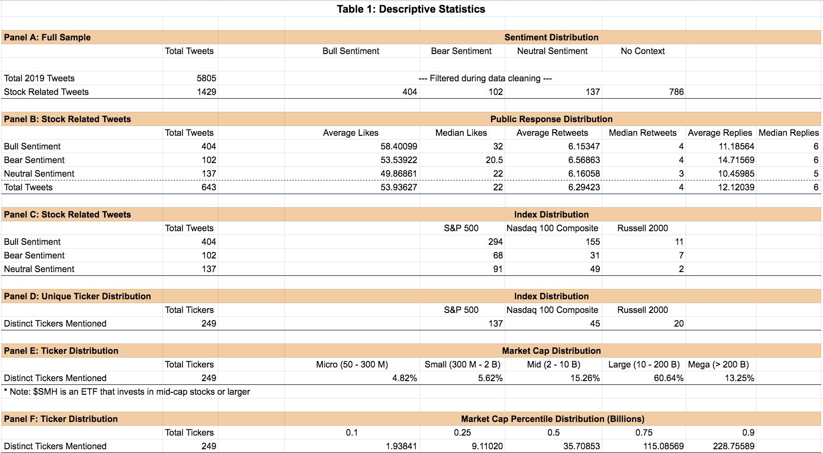

**Table 2: Comparisons of Stock Returns vs. S&P 500**

|  |  |  |  |
| --- | --- | --- | --- |
| **Comparisons of Returns post Jim’s tweets (Buy Recommendations)** | | | |
|  | **1-Day** | **7-Day** | **30-Day** |
| Average Difference | 0.31% | 0.59% | 0.72% |
| Confidence Interval | (-0.12%, 0.75%) | (0.04%, 1.13%) | (-0.29%, 1.74%) |
| P-value | 0.0782 | 0.0383 | 0.0816 |
| **Comparisons of Returns post Jim’s tweets (Sell Recommendations)** | | | |
| Average Difference | -0.33% | -1.43% | -0.86% |
| Confidence Interval | (-1.3%, 0.64%) | (-3.14%, 0.28%) | (-3.61%, 1.89%) |
| P-value | 0.2514 | 0.0506 | 0.2677 |
| **Comparisons of Returns pre Jim’s tweets (Buy Recommendations)** | | | |
| Average Difference | 0.89% | 1.57% | 3.78% |
| Confidence Interval | (0.43%, 1.36%) | (0.78%, 2.35%) | (2.56%, 5.01%) |
| P-value | 0.0001 | 5.70558e-05 | 1.86096e-09 |
| **Comparisons of Returns pre Jim’s tweets (Sell Recommendations)** | | | |
| Average Difference | -0.67% | -1.96% | -2.24% |
| Confidence Interval | (-0.13%, -0.09%) | (-3.95%, 0.03%) | (-6.64%, 2.16%) |
| P-value | 0.0300 | 0.0527 | 0.1995 |

**​​**

**Table 3: Regression Results on Short Term Stock Returns**

|  |  |
| --- | --- |
| **Bullish Statements** | **Bearish Statements** |
| **Regression results on 1-day return** | **Regression results on 1-day return** |
| **Regression results on 1-week return** | **Regression results on 1-week return** |
| **Regression results on 1-month return** | **Regression results on 1-month return** |

**Table 4: Frequency of Each Stock Mentioned by Cramer**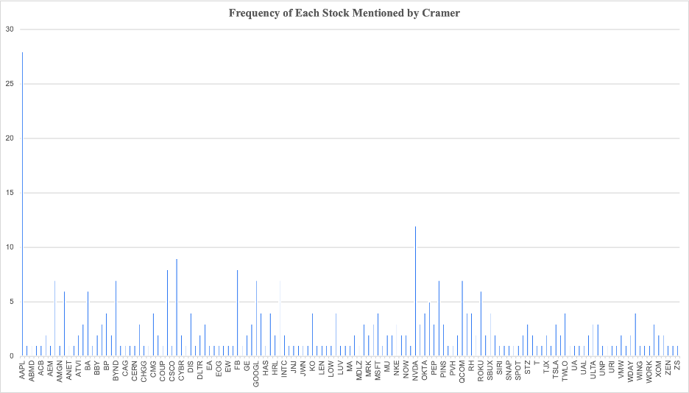

**Table 5: Portfolio Return vs. S&P 500 Return**

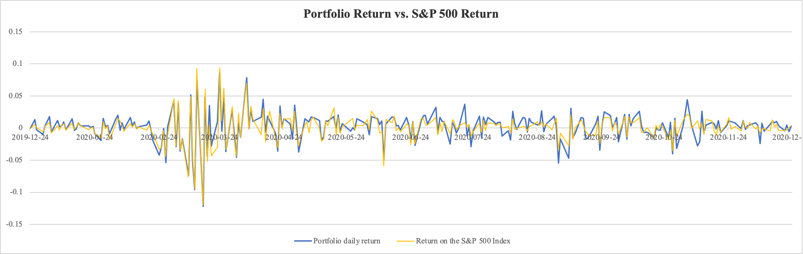

**Table 6: Regression results**

**Panel A: Regression with one factor (mktrf)**

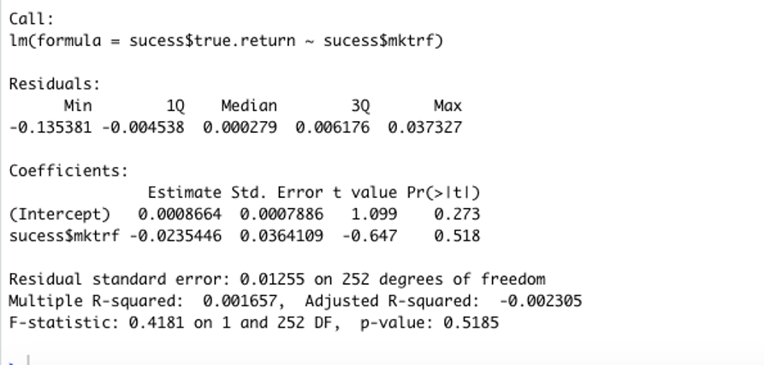

**Panel B: Regression with all 5 factors**

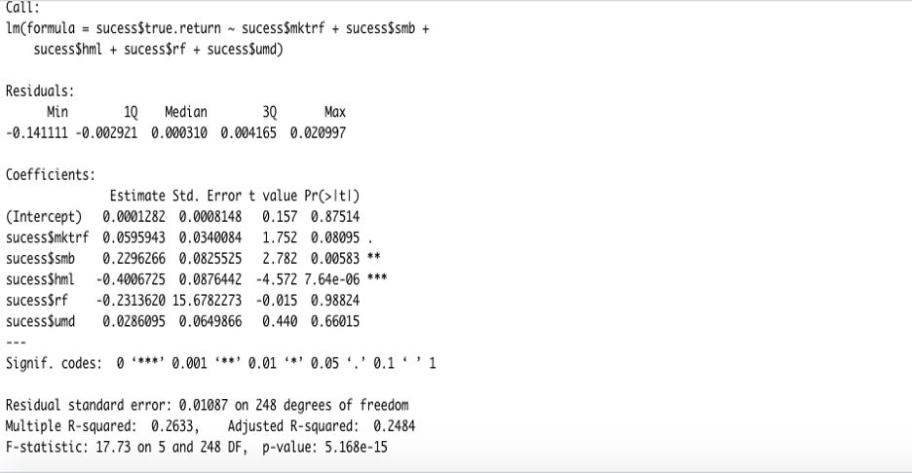

**References:**

​​Bolster, P. J., Trahan, E. A., & Venkateswaran, A. (2011). *How Mad is Mad Money: Jim Cramer*

*as a Stock Picker and Portfolio Manager.* Boston: Northeastern University.

Engelberg, J., Sasseville, C., & Williams, J. Market Madness? The Case of "Mad Money". *SSRN*

*Electronic Journal*, 2010, doi:10.2139/ssrn.870498.

Pisani. (2021, January 22). *Trading volume is up from 2020's breakneck pace as retail investors*

*jump in*. CNBC. <https://www.cnbc.com/2021/01/22/trading-volume-is-up-so-far-from-2> 020s-breakneck-pace-as-retail-investors-get-even-more-active.html.